OSP Icon Essential Skill Sample Tasks

 | Reading Text  Reading materials in the form of sentences or paragraphs such as notes, letters, memos, manuals, specifications, books, reports and journals. | • Read captions under a picture.  • Read magazines, comics, chapter books... anything!  • Read a movie review to decide if you want to go and  see it.
 | Writing  The preparation of written materials for  a variety of purposes. Completing such tasks as filling in forms, writing text and using computers to write. | • Write short reminder notes in an agenda or daily planner.  • Write entries in a diary.  • Write a short story.  • Write a book report.
 | Document Use  Reading different types of material such as labels, signs, lists, tables, graphs, forms, diagrams, blueprints and other similar material. | • Read signs in the community.  • Use an agenda to record due dates for assignments.  • Check the sports scores in the newspaper to identify which teams won last night.  • Use maps and graphs in a project.
 | Computer Use  The use of any type of computerized technology. | • Login and use a mouse on a computer.  • Use computers at home and in class.  • Explore new technology at home or in class.  • Send and receive e-mail messages.
 | Oral Communication  Using verbal skills to exchange ideas and information with others. | • Ask a friend or adult for something I need.  • Answer questions in class and give presentations.  • Order food in a restaurant.
1
Numeracy

OSP Icon Essential Skill Sample Tasks

 | Money Math  The use of mathematical skills in making financial transactions, such as handling cash, preparing bills, and making payments. | • Know the names of coins and their monetary value.  • Add coins and bills.  • Calculate how much money the class raised in a  fundraiser.
 | Scheduling or Budgeting and  Accounting  Planning for the best use of time and money, as well as monitoring the use of time and money. | • Read the class schedule and plan time to study for a quiz.  • Schedule time to complete homework and other activities like hockey practice or music lessons after school.  • Look for the best deal when buying something to keep on budget.
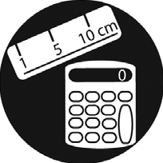 | Measurement and Calculation  The measurement and calculation  of quantities, areas, volumes, and/or  distances. | • Determine how many plates and cups are needed to set a table for the family.  • Help measure ingredients to make a simple meal.  • Weigh yourself to make sure you are within a healthy range for your height.  • Figure out how many cupcakes are needed for a sports team fundraiser.
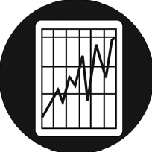 | Data Analysis  The collection and analysis of data in numerical form. | • Compare marks on two assignments to determine whether skills are improving.  • Compare two foods to determine which one is the  healthier choice.  • Calculate course grades by averaging marks received on assignments.  • Predict which sports team will win using game statistics over a period of time.
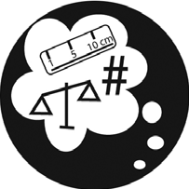 | Numerical Estimation  The production of estimates in numerical terms. | • Guess how many scoopfuls of sand are needed to fill a pail.  • Estimate the time it will take to read a book or complete an assignment.  • Track the wins and losses of a favourite sports team.
2
Thinking Skills

OSP Icon Essential Skill Sample Tasks

 | Job Task Planning and  Organizing  Planning and organizing your own work. | • Pack your backpack with the things needed for  school.  • Help organize events like school bake sales or parties.
 | Decision Making  Making a choice among options using appropriate information. | • Make choices about what clothing to wear based  on the weather forecast.  • Select the materials or equipment needed to complete a craft project or play a sport.  • Select the assignment to work on first using due dates and the relative difficulty of each assignment.  • Look at all options before making a decision.
 | Problem Solving  The identification and solving of problems. | • Complete puzzles.  • Solve riddles.  • Ask others to join the team when there is not enough people to play the game.
 | Finding Information  The use of a variety of sources, including written text, people, computerized databases, and information systems. | • Find the washroom or drinking fountain by asking an adult for help.  • Find information about a favourite music star.  • Find out when the project is due by asking the  teacher or another student.
 | Critical Thinking  Making judgments by using criteria to evaluate ideas and information and the related consequences. | • Judge the suitability of art supplies to complete a project.  • Judge the suitability and reliability of using different websites for a project.  • Use rubrics provided by the teacher to decide if an assignment is ready to hand in.
3

